MASKS REQUIRED
Face coverings are required in this space to help prevent the spread of COVID-19.
NOTICE
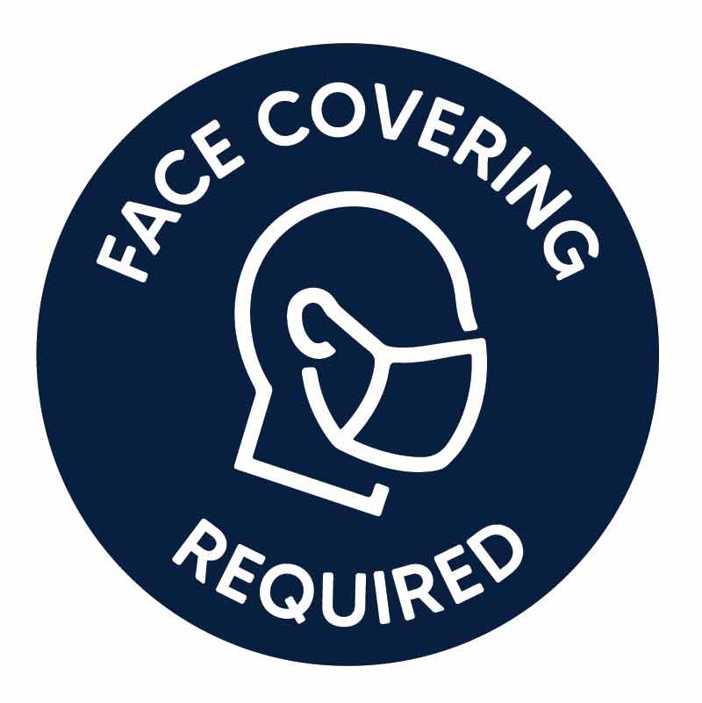
Thank you for your cooperation.
(Mask mandate by order of the Traill County
Commission, dated Nov. 4, 2020.)
If each of us wears a mask, everyone is protected.
